Restaurant footfall prediction.

We are predicting the customer footfall using time series technique. After the prediction we can also work on the inventory required based on the count of customers expected to come.

Also predicting the inventory will help reduce cost and wastage of the product which happens by over production of foods.

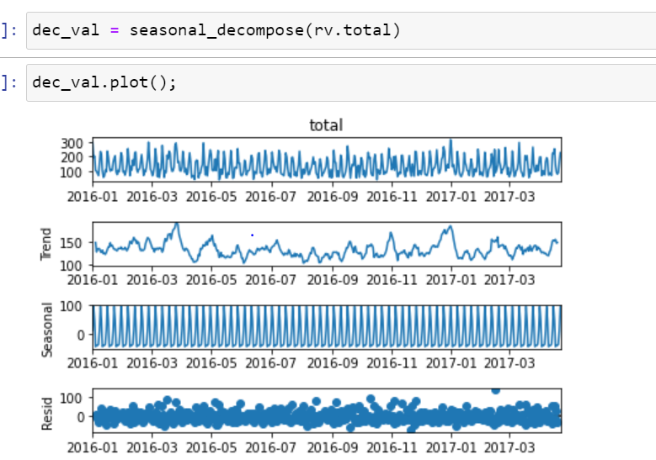

Based on the Auto- arima model we can also predict the footfall for holidays and festivals based on the historical data. Inventory cost can also be planned based on festival days and holiday so to improve cost and also reduce wastage.

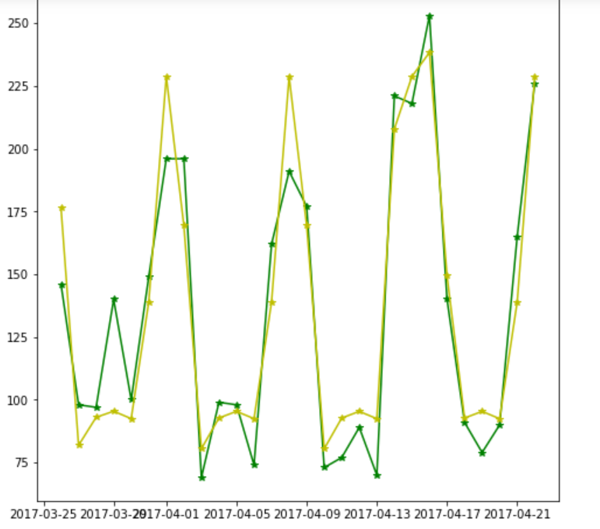

Below algoritms used to understand the review given by customers.

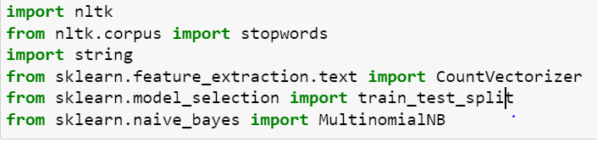

Based on the below we can understand the most used words in the review given by customers. This will be helpful to understand the customers mind and also to improve the business.

